**Dashboard Implementation**

**Instructor: Asmaa Elbadrawy**

Brain Boosters Teamsmates:

Sai Sushank Manthri Pramod

Lakshman Sai Yaganti

Tej Thanush Chowdary

Due Date: Apr 21, 2024

**Section 1: The Dashboard**

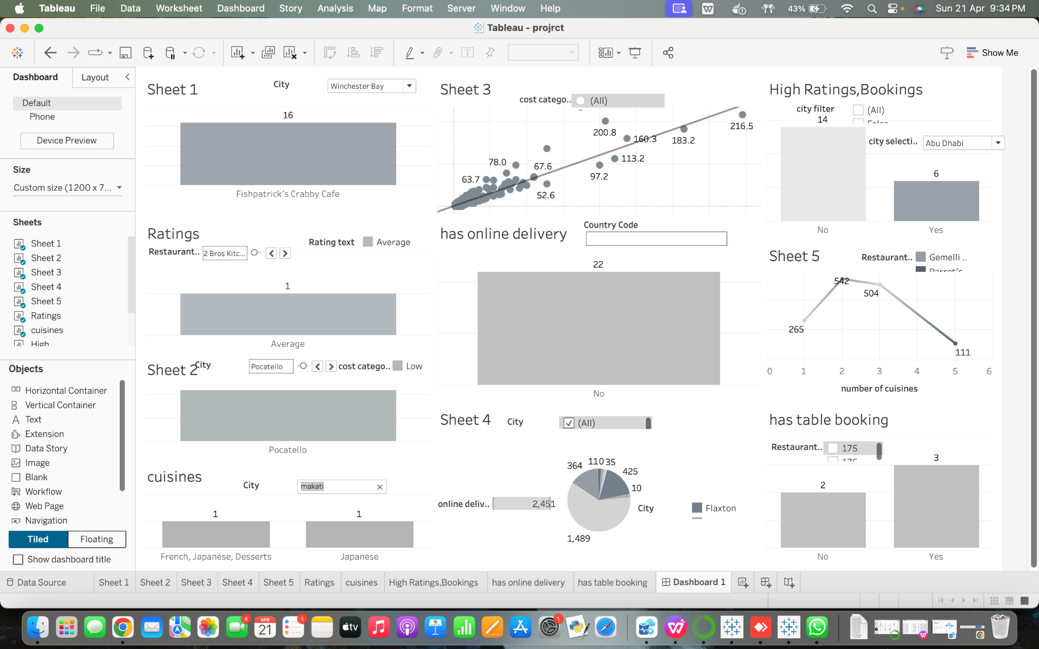

The Tableau dashboard is an assortment of restaurant-related visual data summaries that shed light on several different areas of restaurant data analytics.

1. Sheet 1: This dashboard portion shows a bar graph for a certain city, which might represent the number of eateries in Winchester Bay or another measure like reviews or votes.
2. Sheet 2: This part, which is devoted to cuisines, appears to offer details on the range of cuisines that are offered in various cities.
3. Sheet 3: This scatter plot shows how the overall evaluations of a restaurant relate to its pricing range. The trend line's positive slope implies that better ratings are correlated with higher pricing.
4. Sheet 4: This section's pie chart most likely shows the distribution of eateries that supply food online across various cities.
5. Sheet 5: The line graph illustrates the correlation between the quantity of cuisines restaurants provide and the number of votes they obtain, serving as a stand-in for popularity.
6. Ratings and High Ratings, Bookings: It appears that more information on restaurant ratings and the quantity of highly rated eateries that accept reservations is provided in these areas.
7. Offers online delivery & table booking: It appears that the quantity of restaurants providing online delivery and table booking services is contrasted in these sections.
8. Has table booking:This kind of graphic is helpful for rapidly determining whether or not the restaurants in the dataset offer table booking services, which can be a crucial component for patrons organizing their meals. It briefly conveys a particular feature of restaurant amenities the availability of table reservations which may have an impact on a patron's selection of eatery.
9. Ratings: The purpose of the sheet is to provide users an understanding of the kinds of reviews and rating categories that are related to restaurants. This might help users assess customer satisfaction or restaurant performance by using the qualitative information gleaned from the reviews.
10. Cuisines: This sheet sheds light on the variety of Makati's culinary scene with sections like "Ratings" and "High Ratings, Bookings," which explore the intricacies of restaurant ratings and the frequency of highly rated eateries with reservations. It makes it possible to quickly evaluate the range of eating alternatives available, which may be useful for consumers looking to try new foods or for companies assessing opportunities and competition in the market.

All things considered, the dashboard functions as an analytical tool for comprehending many aspects that might influence a restaurant's popularity and patron preferences, including the variety of cuisines offered, pricing schemes, the availability of online delivery, and reservation facilities.

**Section 2: The Data Set**

The dataset provided for examination comprises a range of restaurant data, from cities and countries each with information about various aspects of the establishments. Each entry in the dataset corresponds to a restaurant, identified by a Restaurant ID" and listed under its "Restaurant Name". The dataset covers an area as shown by the "Country Code" column and offers localized details including "City" "Address" "Locality" and "Locality Verbose".

Essential location data is given through the "Longitude" and "Latitude" coordinates enabling analysis and mapping of restaurant positions. The array of cuisines at each restaurant is documented in the "Cuisines" section showcasing the culinary offerings within this dataset. Furthermore, financial aspects like the transaction currency. The price range is included, which could provide insights into each restaurant's market position.

Details about features of the restaurants are also provided, such as their table booking availability ("Has Table booking") and online delivery services ("Has Online delivery") along with information, on delivery status ("Is delivering now") and whether an order menu switch feature is available ("Switch to order menu").

Customer opinions are measured using the "Aggregate rating," along with a "Rating color" and "Rating text" to show how well a restaurant is doing in the eyes of its customers visually and in writing. The "Votes" section indicates the level of interaction and feedback gathered from customers.

This detailed collection of data gives a perspective on the restaurant sector allowing for examination on different fronts, like location spread, food preferences, service highlights and customer happiness measures.

Several procedures may be done to guarantee that the information is clean and suitable for display to prepare the information and eliminate undesirable symbols like "�".  
Initially, data exploration methods may be used to go through the information to find these symbols. This entails examining the information to look for any irregularities or discrepancies and figuring out which particular letters or symbols should be eliminated. Once detected, manipulation of data techniques like string replacements or filtering can be used to change or delete these characters.

Secondly, cleaning data techniques can be used to address values that are lacking or corrupted, since these could be the reason why undesirable symbols are showing up. This might entail interpolating values that are missing based on nearby data points, assigning values that are missing, or deleting columns or rows with a high percentage of missing data. Unnecessary characters in the data set can be lessened by filling in the missing values.

Lastly, to guarantee uniformity and consistency in the data, standardization and normalizing procedures might be used. This might entail standardizing numerical data formats, eliminating punctuation and particular characters, and converting textual data to lowercase. We can guarantee that the data is in a clear and consistent format that is appropriate for visualizing and analyzing it by standardizing it.

We can efficiently clean and prepare the information for visualization by putting these pretreatment processes into practice. This ensures that undesired symbols, such as "�" are eliminated and the information is prepared for insightful interpretation and analysis.

**Section 3: Dashboard Users**

Restaurants with the most votes and correlation with ratings: Managers and owners may assess how well-liked their establishment is in comparison to others, and analysts can determine whether a high vote count is correlated with a high rating to learn more about the preferences of their patrons. Customers may utilize this to find well-liked restaurants.

Average cost for two per city & cuisine: Based on location and preferred cuisine, customers may estimate their eating costs, and owners/managers can modify their pricing tactics appropriately.

Price range and rating correlation: Owners/managers may determine whether their pricing reflects what customers consider to be a good deal, and customers can determine whether higher prices are often indicative of greater quality.

Restaurant owners and managers can strategically plan their menu selections to draw in more patrons, and researchers can analyze how a diverse menu influences consumer preferences.

Counting the total number of ratings that every restaurant has gotten: While researchers measure customer interaction, owners/managers may monitor their restaurant's popularity over time and compare it to that of their competitors.

Total culinary options by city: While owners and managers may evaluate market saturation and possible niches, consumers can discover the variety of cuisines found in various cities.

Ratings and table booking choices: Customers can rank restaurants with this feature higher if it is linked to higher ratings, and owners/managers can choose whether to provide table booking options depending on possible rating influence.

Variability in online meal ordering depending on distinct nation pin codes: While analysts may spot patterns and possibilities in various locations, owners and managers can customize their online ordering services based on customers' preferences.

**Section 4: Questions**

1. Which restaurants have the highest number of votes and how does it correlate with their ratings?
2. How does the average cost for two vary by city and cuisine?
3. How do ratings correlate with the price range of restaurants?
4. Which cities have the highest number of restaurants offering online delivery?
5. How does the number of available cuisines affect restaurant popularity in terms of votes?
6. How to find total number of ratings for every restaurant?
7. How to find total number of cuisines based on city?
8. Do restaurants with table booking options tend to have higher ratings?
9. How does online food ordering vary across different Country pin codes?
10. How does the frequency of table bookings correlate with the overall count of restaurants?

**Section 5: Plots**

1. Which restaurants have the highest number of votes and how does it correlate with their ratings?

The horizontal axis (x-axis) of the bar chart shows the names of the restaurants, while the vertical axis (y-axis) shows the total number of votes. The total number of votes that each restaurant has gotten is shown by the length of each bar. By examining the longest bars on the dashboard, we can determine which restaurants are in the top few with the most votes.In terms of the correlation with ratings, the ratings are not visible immediately on the bar chart; nevertheless, the upper right section of the filter appears to let us choose the city and displays a range for "SUM(Aggregate rating)" between 3.600 and 4.900.

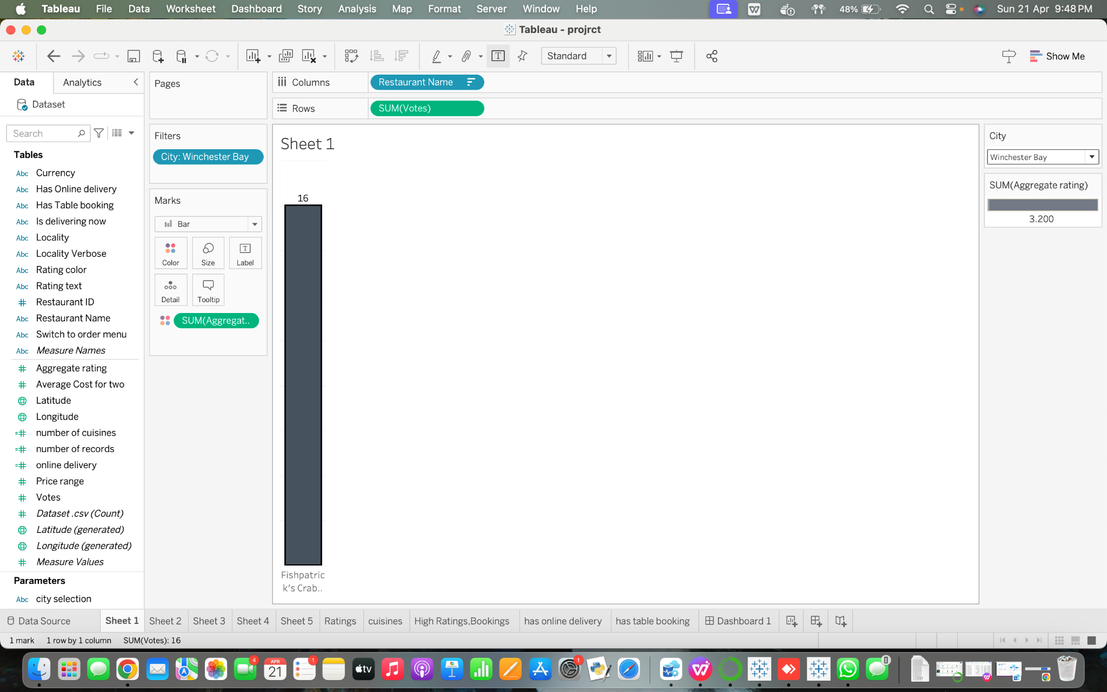

2. How does the average cost for two vary by city and cuisine?

The "Average Cost for Two" statistic, which is shown on the y-axis, is the average that is displayed in the bar chart. This data is categorized by city on the x-axis. Nevertheless, we are unable to directly compare across different cities from this perspective because the graphic presently only displays data for Abu Dhabi. We would need to either remove the city filter or modify it to include more cities in the chart in order to see how the average cost for two differs by city. Regarding cuisine, we can observe that there is a detail with the name "Cuisines - Split 1" in the "Marks" section, indicating that the data may be categorized according to the kind of cuisine. However, the visualization does not show this breakdown at this time, much like the city filter does.

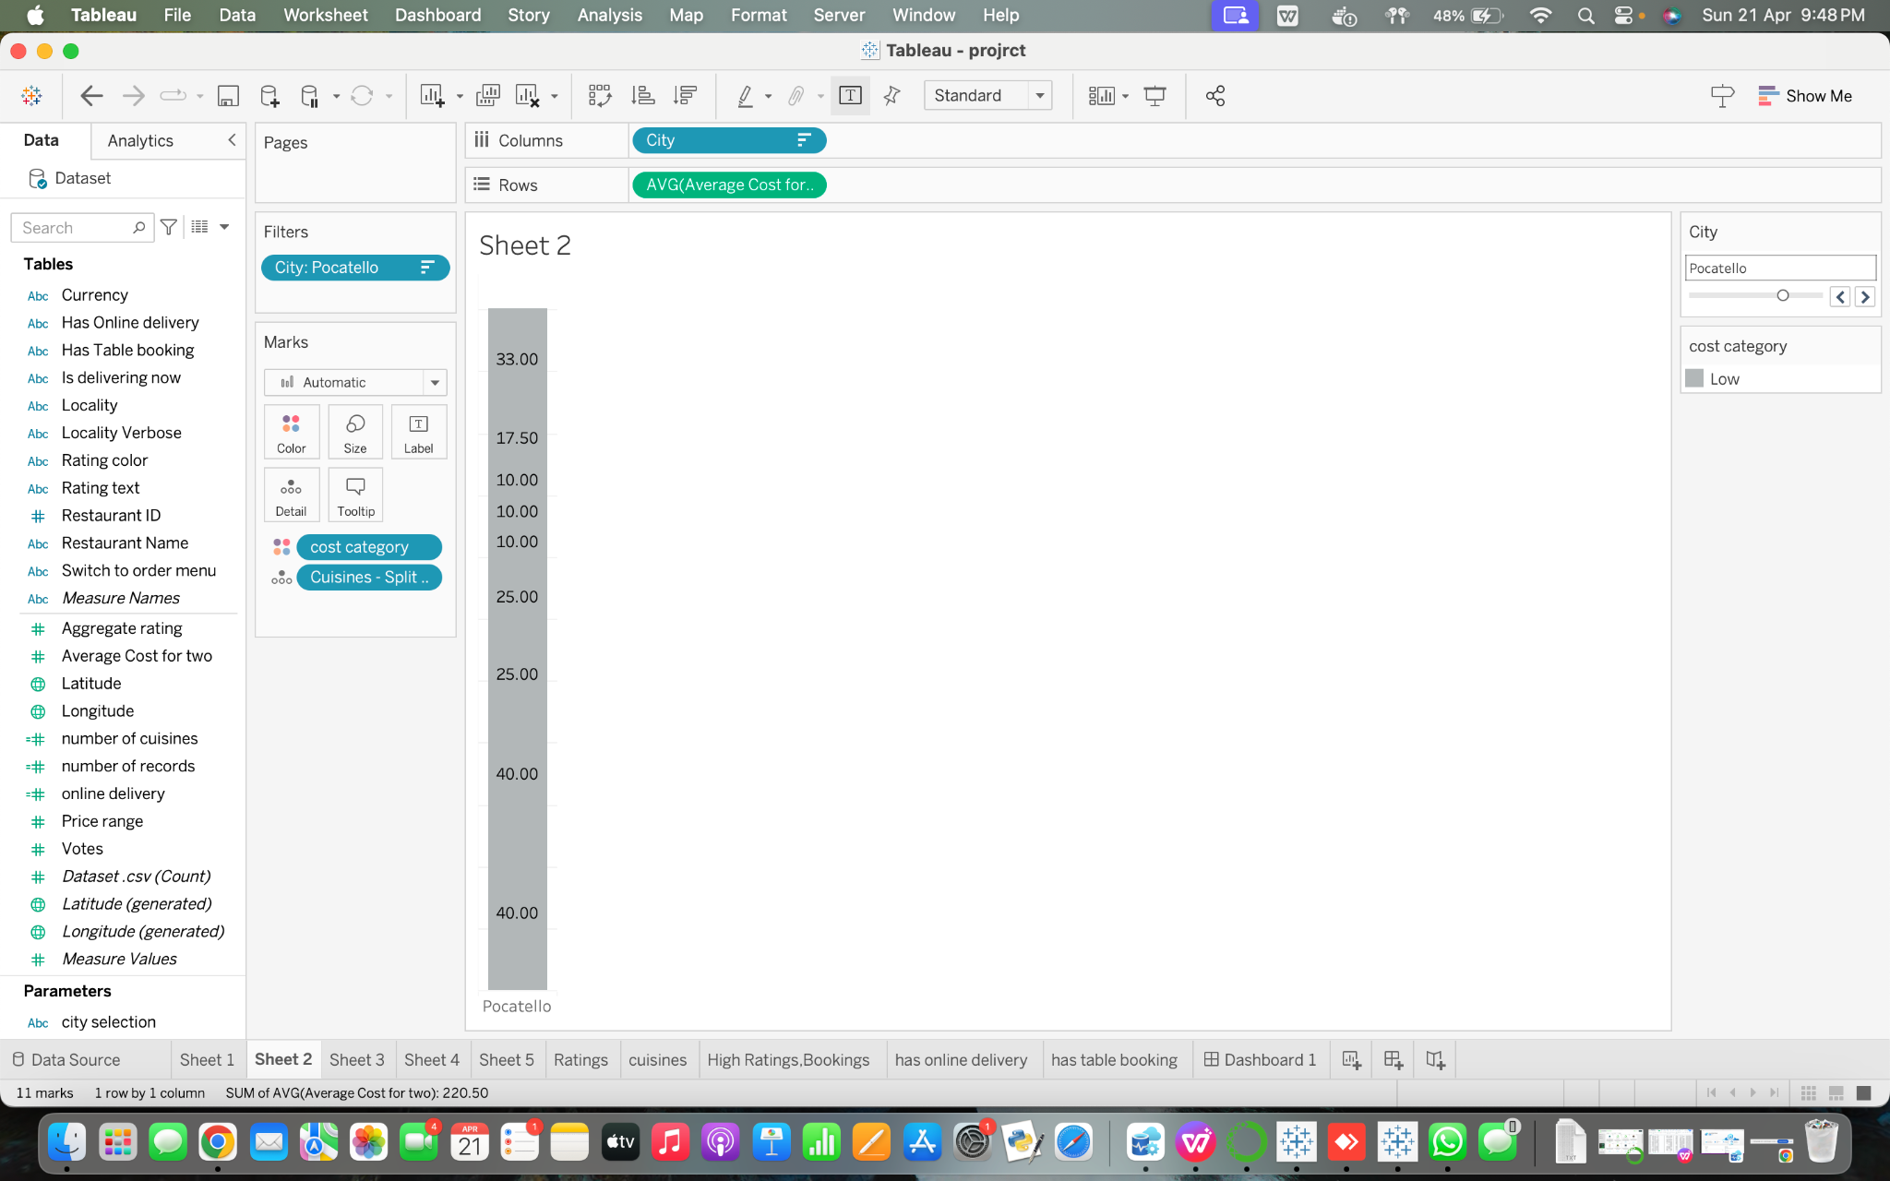

3. How do ratings correlate with the price range of restaurants?

Positive correlation denotes that the aggregate rating tends to rise along with the price range when the points in the plot tend to move from the bottom left to the top right. There is a negative association if the points tend to travel from the top left to the bottom right. This means that the aggregate rating tends to decline as the price range increases.Based on this specific scatter plot, it appears that there is an upward tendency. The line of best fit, or straight line, which slopes upward from left to right across the cloud of data points, graphically supports this. This implies that there may be a positive relationship between the overall rating and the price range.

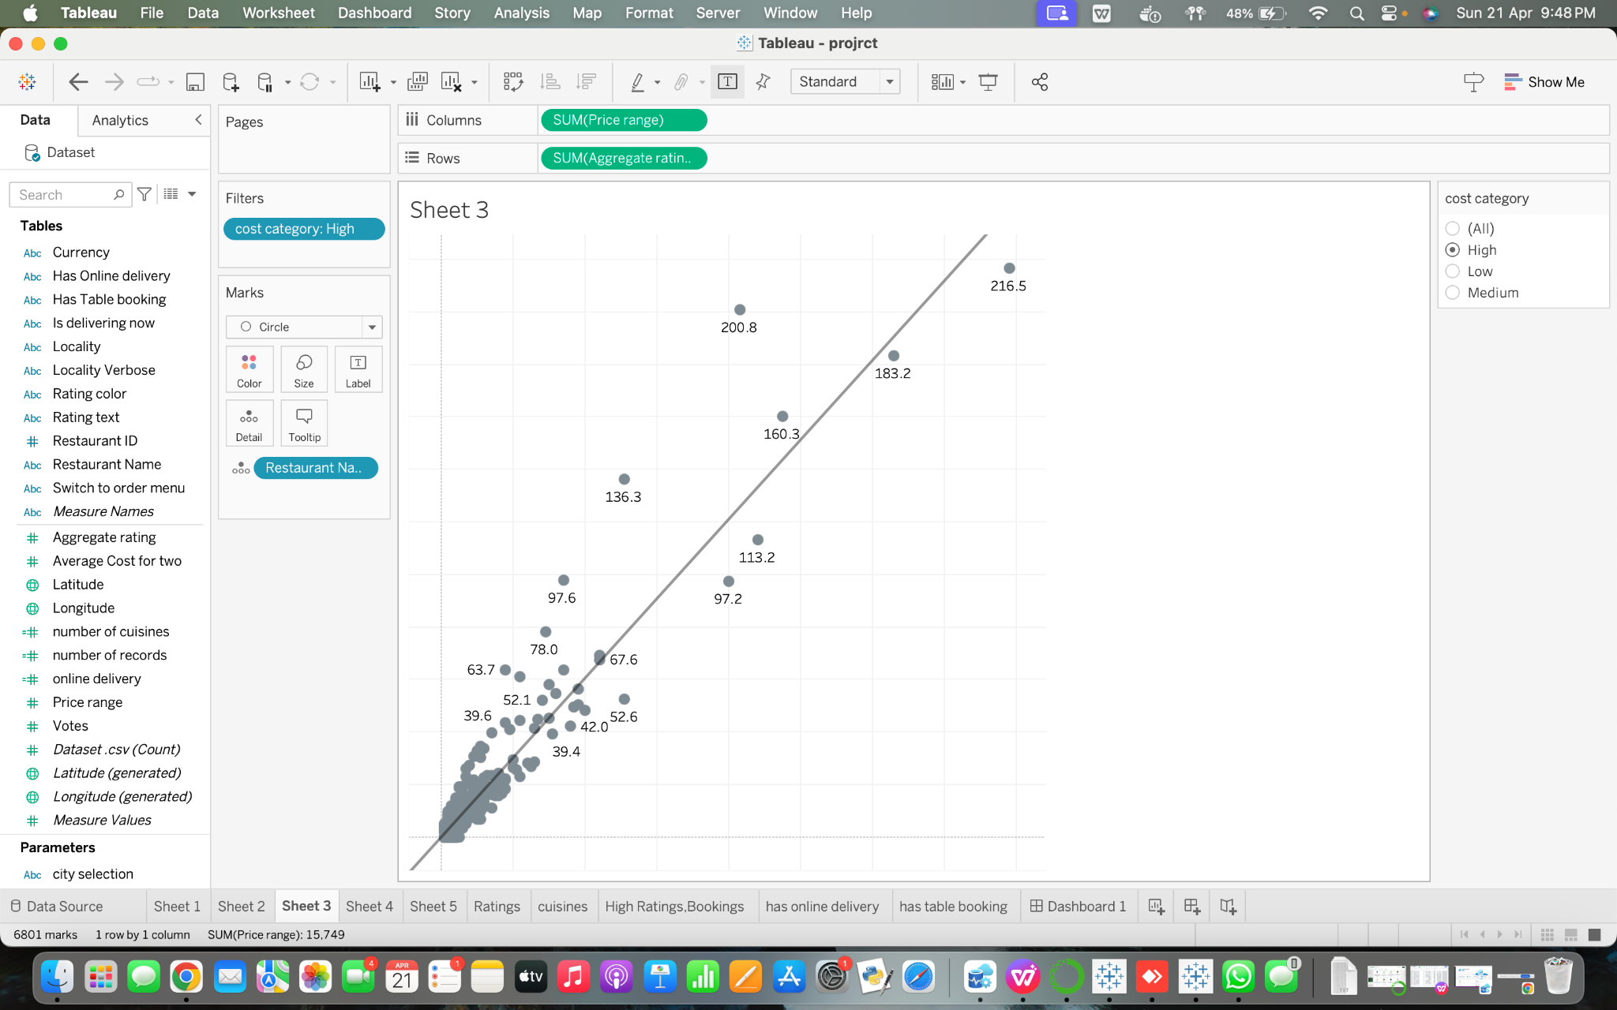

4. Which cities have the highest number of restaurants offering online delivery?

You would search for the largest pieces of the pie to find out which cities have the most eateries that deliver food online. These slices make up a larger percentage of the total, which in this case is the total number of eateries in all the cities covered that provide online delivery. Which city each slice refers to is indicated by the colors or labels (if available while hovering over the slices or in a legend).Students would match the names of the appropriate cities with the biggest slices that they could find. They could also be able to click or hover over slices to see actual figures if the pie chart is interactive. If so, they may have to depend on visual estimates to find out which towns have the greatest number of eateries that

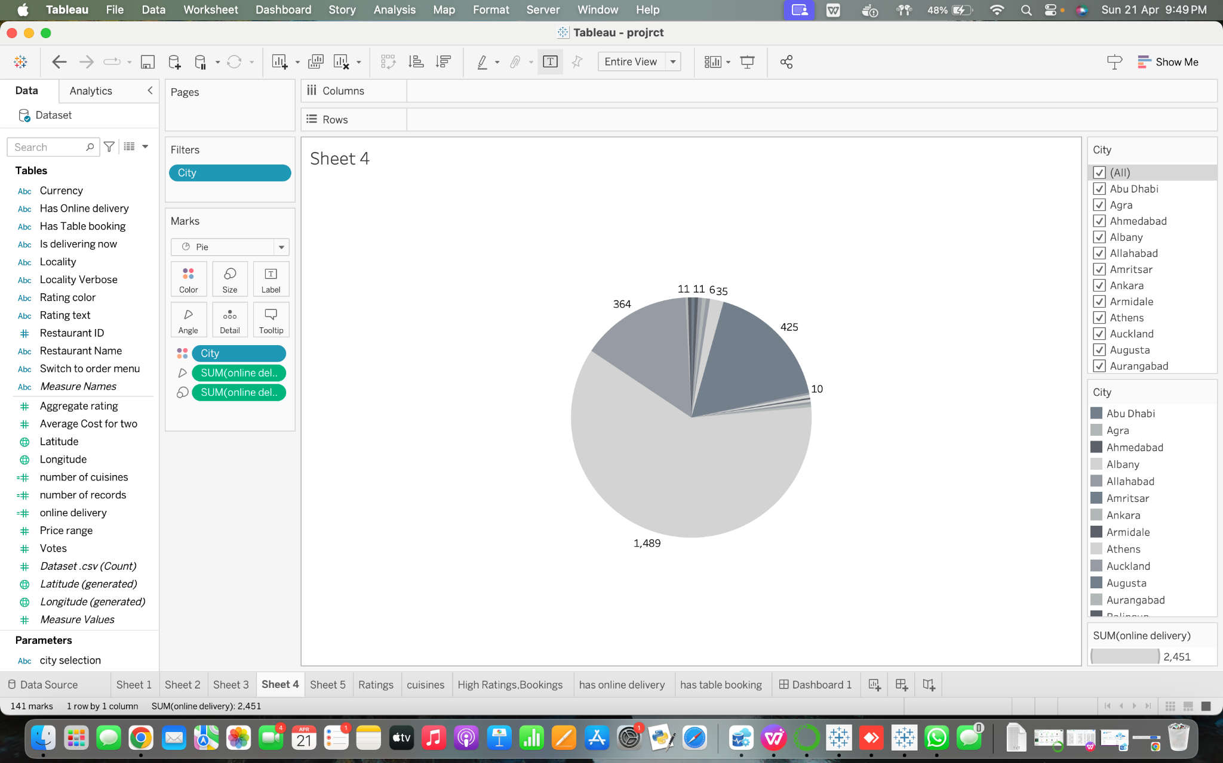

5. How does the number of available cuisines affect restaurant popularity in terms of votes?

According to the graph, the number of votes for restaurants that serve a particular number of cuisines peaks and then declines. We may talk about what this pattern indicates about restaurant popularity in connection to the range of cuisines provided in a classroom context. A certain number of cuisines is correlated with the largest number of votes, as indicated by the peak. Finally, the line graph concludes by illustrating the correlation between the popularity of the restaurant—as determined by the votes—and the diversity of its menu. We may also think about looking at other data points or doing surveys to get more insights into customer preferences in order to better understand this link.

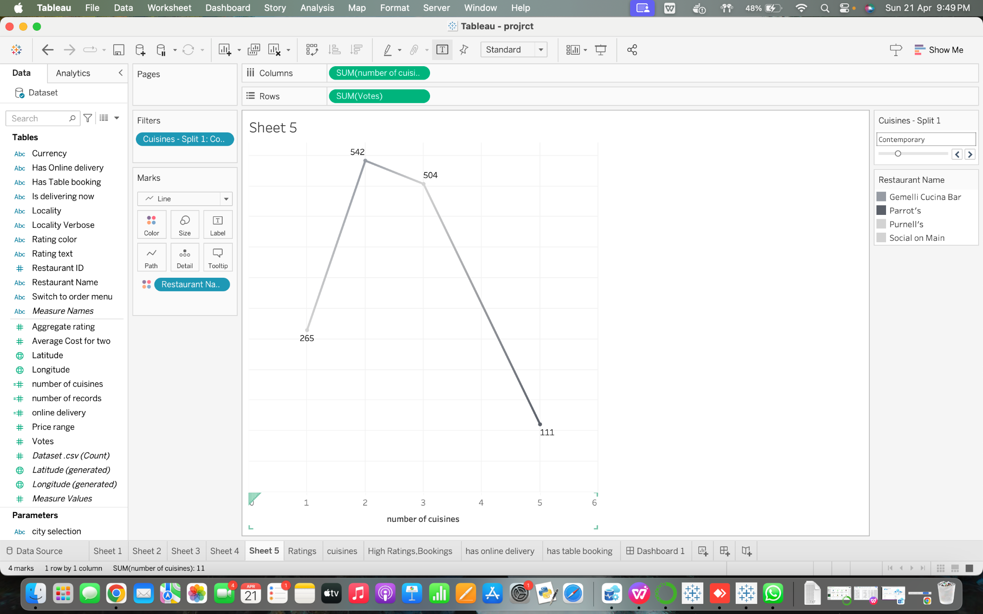

6. How to find the total number of ratings for every restaurant?

* A bar chart showing the distribution of ratings for a particular restaurant is shown in the plot. The height of each bar, which represents a distinct rating category (such as 1-star, 2-star, etc.), relates to the number of reviews in the dataset that fit into that rating category.
* Questions answered:

How are the ratings for a certain restaurant distributed?

* By giving a visual depiction of the distribution of ratings (such as 1-star, 2-star, etc.) for a certain restaurant, this plot aids in the response to the question. Utilizing the interactive interface, users may choose the title of a restaurant, and the plot changes constantly to display the rating distribution for that restaurant.
* How It Responds to the Inquiries:

Interactive Control: The plot makes use of a single sliding bar for interactive control, allowing users to slide between the alternatives to choose the name of the restaurant.

Dynamic Update: The graphic changes continuously to show the distribution of ratings for the selected restaurant when a restaurant name is selected. This enables customers to rapidly see the distribution of ratings for a certain restaurant across multiple groups.

Bar Chart Representation: Users can easily understand the distribution of ratings when a bar chart is used. A distinct rating category is represented by each bar, and the height of the bars makes it evident how many reviews are associated with each rating category.

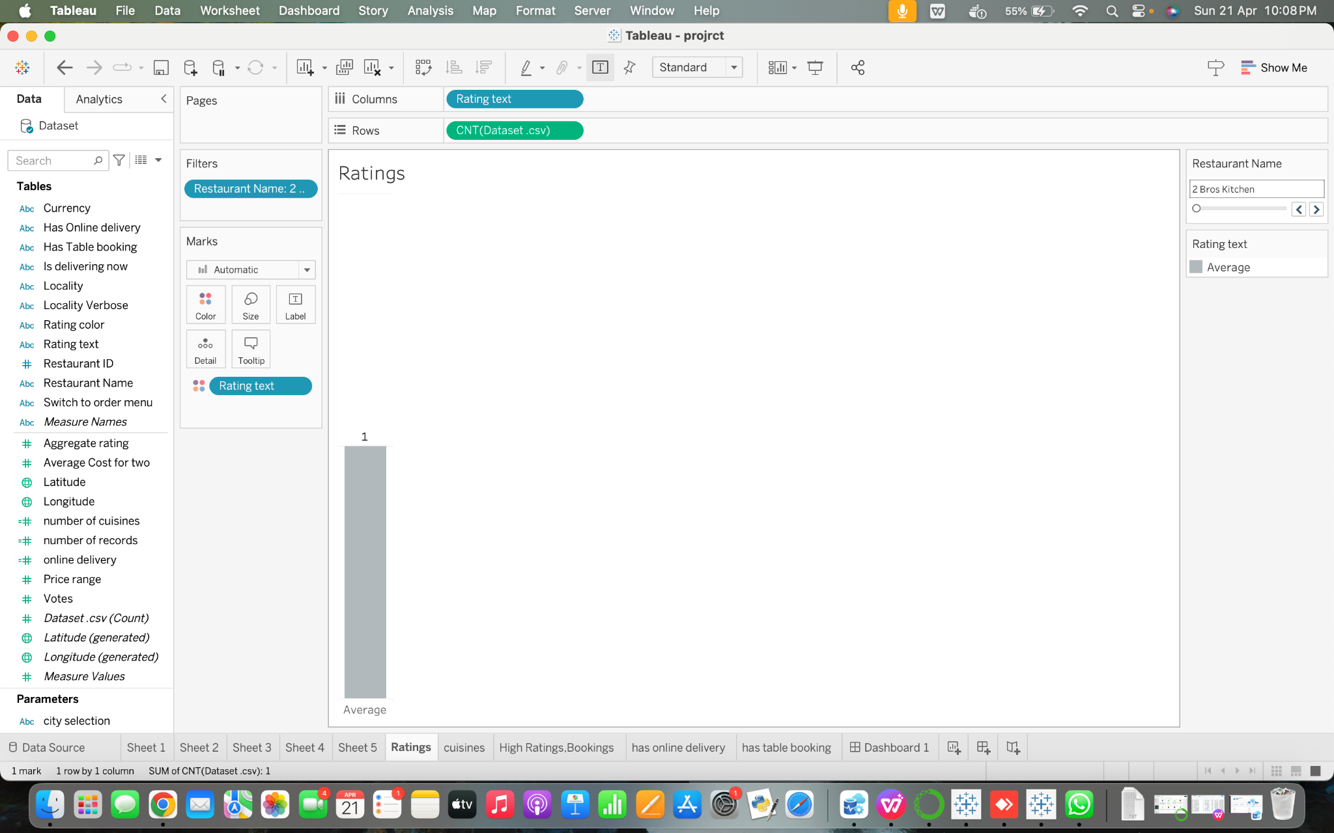

7. How to find the total number of cuisines based on the city?

* Plot Overview:

The plot displays a bar chart that shows how different cuisines are distributed throughout a chosen city. Every bar symbolizes a distinct cuisine, and the number of restaurants in the selected city that serve that particular cuisine is indicated by the overall height of the bars.

* Questions answered:

What kind of cuisines are offered in a certain city?

The storyline sheds light on the range of cuisines available in a chosen city. Utilizing the interactive control, users may select a city, and the map will dynamically change to show the spread of cuisines offered in that city.

* How It Responds to the Inquiries:

Interactive Control: Users can choose a city by entering its name in the wild card match search interactive control. Thanks to this, customers can easily find and select their preferred city from a list of possibilities.

Dynamic Update: The figure dynamically updates to display the spread of cuisines accessible in the selected city when a city is selected. Users may get up-to-date information on the variety of cuisines in a certain area with this constant updating capability.

* Bar Chart Representation: The distribution of cuisines may be easily seen by using a bar chart. Every bar symbolizes a distinct cuisine and the number of restaurants serving that food in the chosen city is shown by the overall height of the bars.

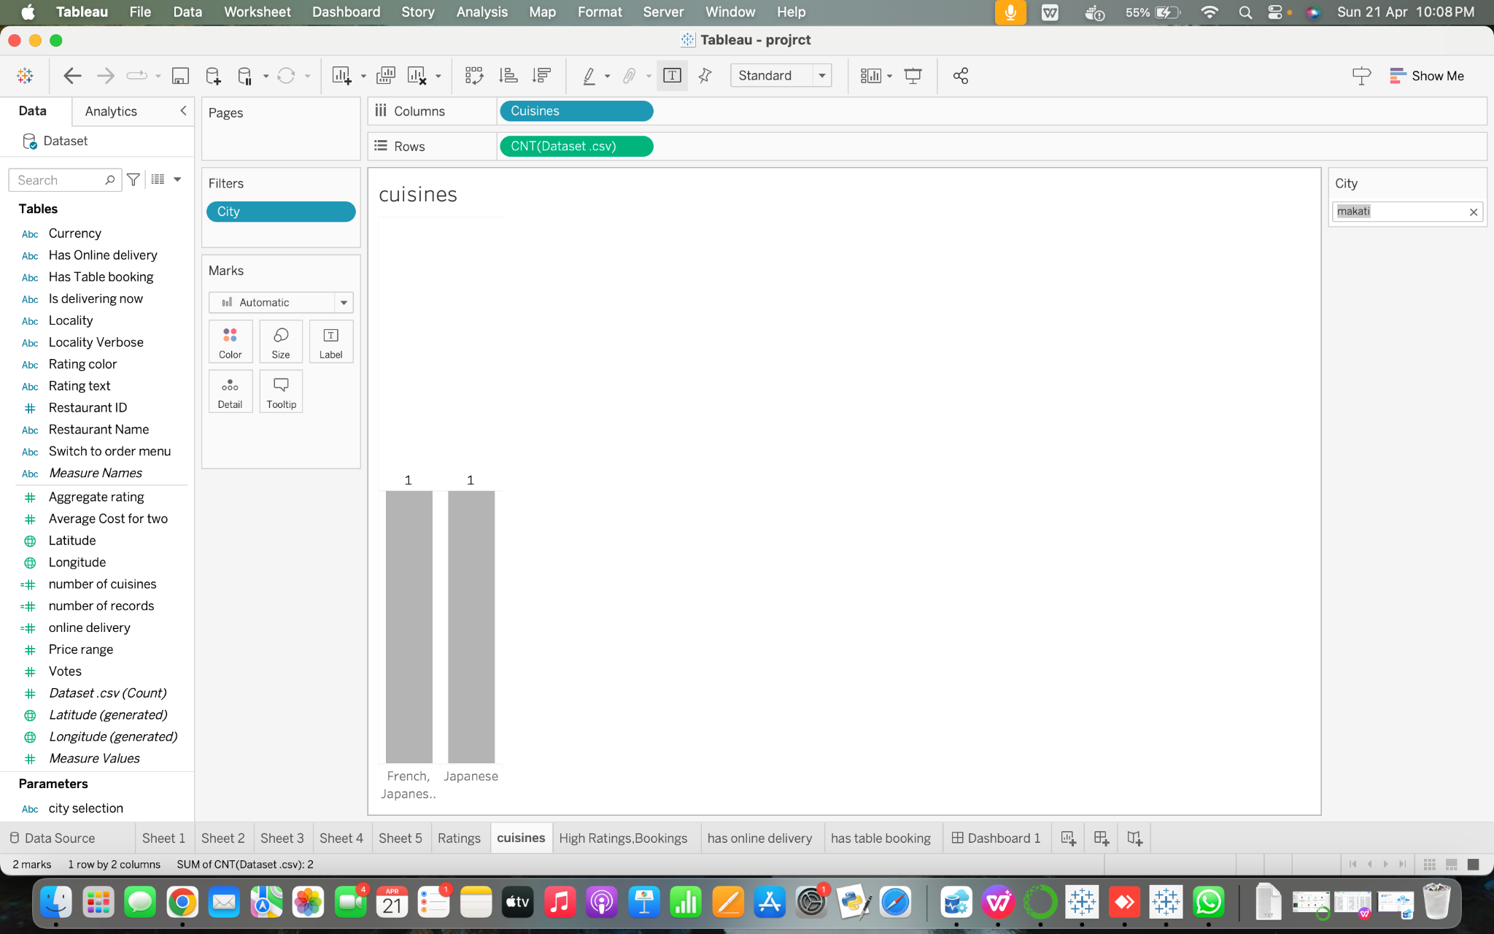

8. Do restaurants with table booking options tend to have higher ratings?

* Plot Synopsis: The plot displays a bar chart that illustrates how restaurants are distributed in a selected city according on the number of table reservations.
* Questions answered:

What is the distribution of available tables among restaurants in a given city?

How It Responds to the Inquiries:

* Interactive Controls: Utilizing dropdown menus, customers may choose a city and filter restaurants according on whether or not they are available for table reservations.
* Dynamic Update: To show the distribution of available table reservations in the chosen city, the map is updated in real time.
* Bar Chart Representation: In the selected city, bars stand in for the number of eateries that provide table reservations and those that do not.

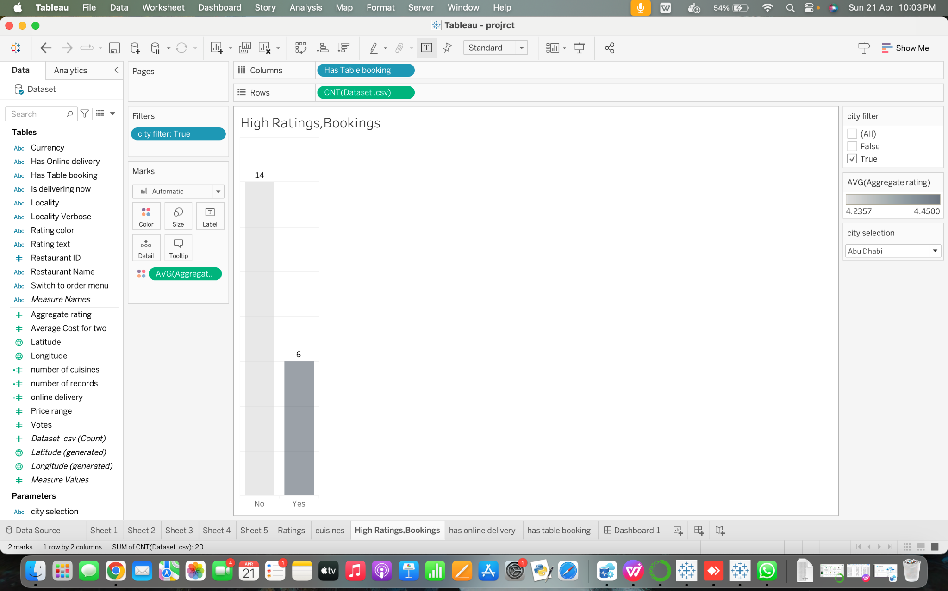

9. How does online food ordering vary across different Country pin codes?

* About online delivery, the plot shows a bar chart that shows the restaurants' spread across each nation. A country's restaurant count for each category is shown by the height of the bars, which each reflect a category that indicates if a restaurant offers online delivery (e.g., "Yes" or "No").
* Addressed Questions:

How widely are eateries across various nations able to provide online delivery?

The Way It Responds to the Queries: Selecting a country code from the single-value list interactive control allows users to concentrate on facts unique to that particular nation.

* Dynamic Update: The graphic dynamically changes to show the distribution of restaurants in a given nation that provide online delivery when a country is selected.
* Bar Chart Representation: The chart shows the number of restaurants in the chosen country that provide online delivery compared to those that do not. This allows for a visual comparison of the availability of online delivery across various nations.

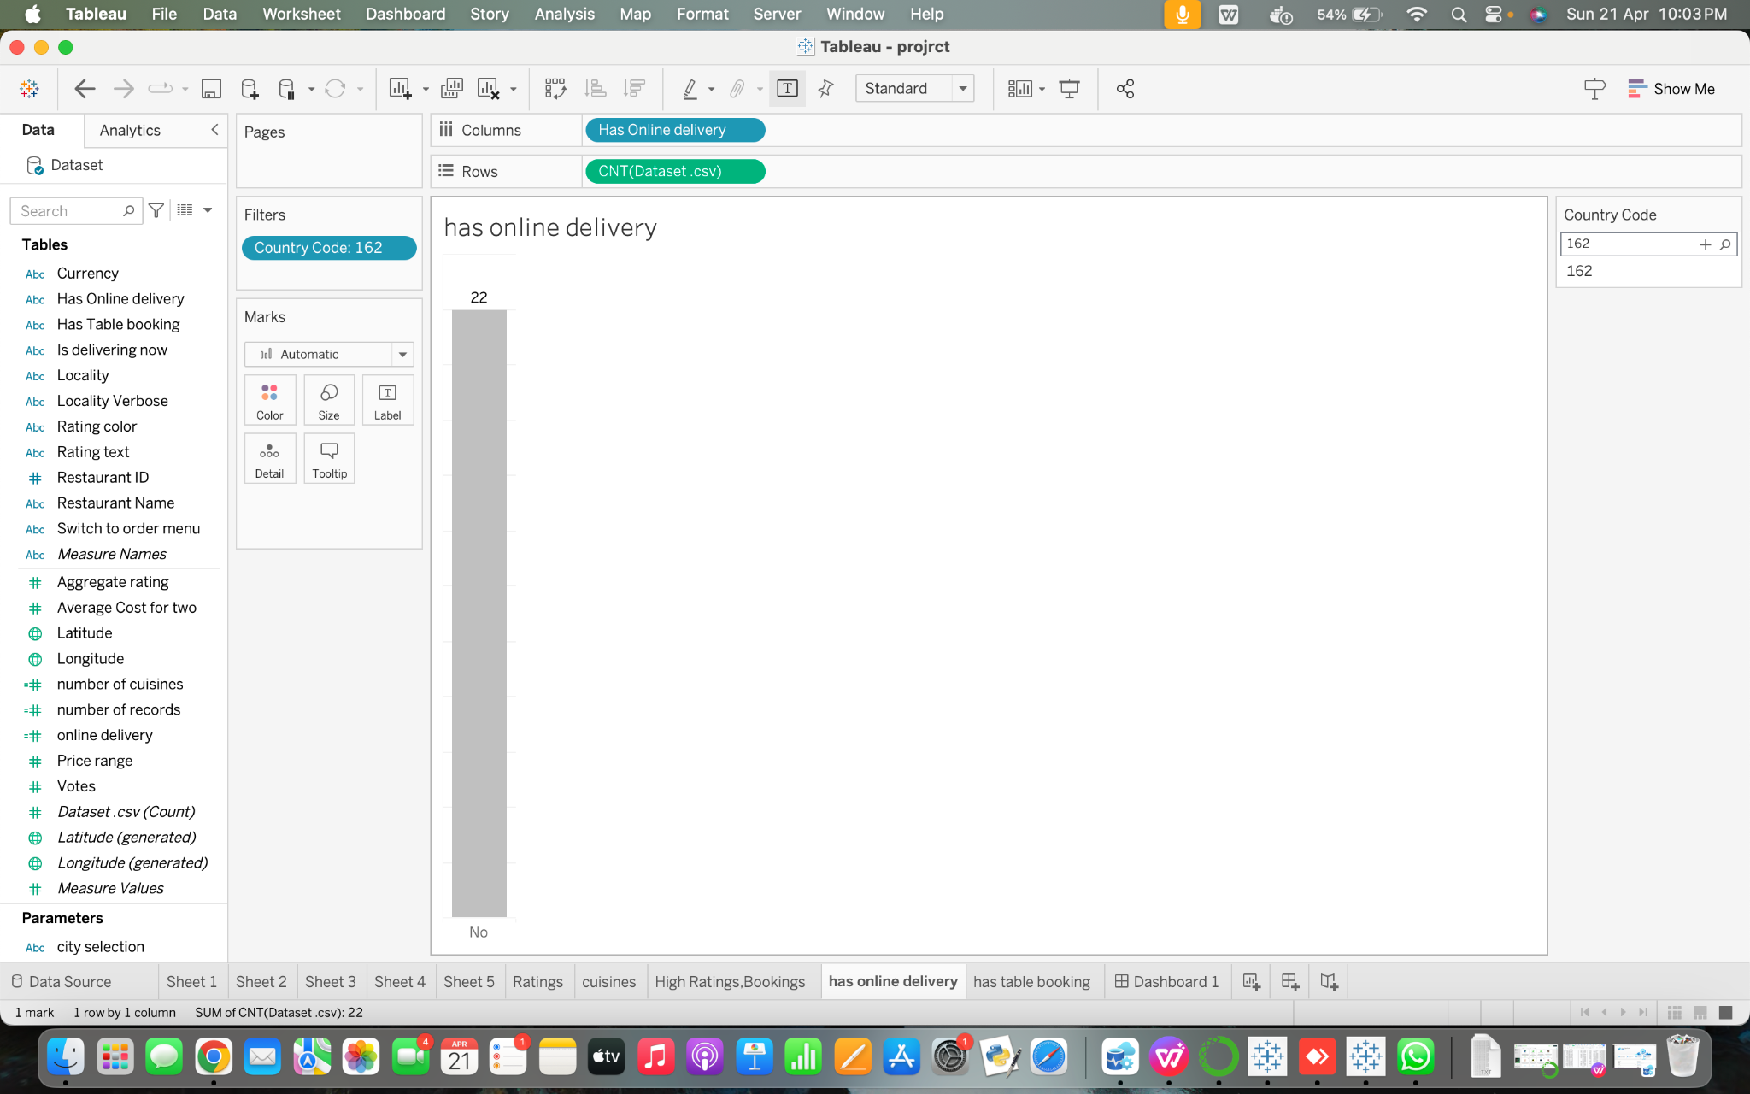

10. How does the frequency of table bookings correlate with the overall count of restaurants?

* A bar chart representing the distribution of eateries with and without table reservations is shown in the plot, according to a particular set of restaurant IDs. Every bar signifies a category that indicates whether or not reservations for tables are available at the restaurant; the number of restaurants that fall into each category is indicated by the height of the bars.
* Addressed Questions:

How many restaurants do you think take reservations for tables versus how many don't?

A graphic depiction of the distribution of restaurants with and without table reservations is included in the plot to answer this question. With the multi-value drop-down interactive control, users may choose individual restaurant IDs to examine the distribution for a selection of eateries.

* Update Dynamically: The plot changes dynamically to show the distribution of restaurants with and without table reservations for the specified restaurant IDs as soon as you pick them. With the help of this dynamic updating tool, consumers can see in real time which restaurants are accepting reservations for tables.
* Bar Chart Representation: It is simple for customers to compare the distribution of restaurants with and without table reservations when a bar chart is used. Every bar signifies a certain category, and the bars' heights clearly show how many restaurants fit into each group.

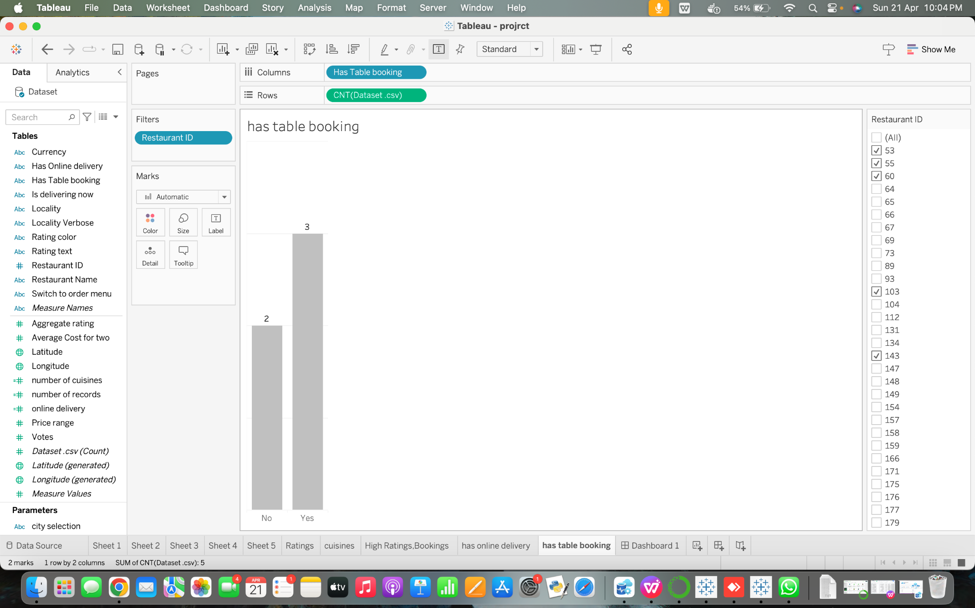

**Section 6: Interactivity**

1. Single Value Dropdown:
   * Functionality: Allows selecting one option from a dropdown menu.
   * Plots Controlled:

Loaded dynamically from the 'City' attribute, including all unique city names present in the dataset.

The Votes Threshold Slider, Rating Slider, City Filter, and Restaurant Filter will all be directly used in this plot. Every restaurant will be displayed as a point plotted against the rating (Y-axis) and number of votes (X-axis). Each point might have a different size or color to represent different data dimensions (like average cost).

Type of chart displaying online bookings for the country.

Value Range: Users can select a country code from the drop-down menu. The list of country codes like 208 in this example is loaded from the Pin codes attribute in the dataset.

1. Single Value Slider:
   * Functionality: Select a single value within a predefined range using a slider.
   * Plots Controlled:

Box Plot or Bar Chart showing the average cost for two. Every distinct city found in the data will be included in the range. The 'City' property in the data will be dynamically loaded to load this control.

Usually ranges from the 'Average Cost for two' attribute's minimum to the highest value. If the dashboard is configured to update this control based on other filters, this range, which is dynamically loaded, might change depending on the city and cuisine filters.

A dynamic approach to investigate theories or identify trends is provided by users' ability to dynamically alter parameters like as the quantity of cuisines or voting thresholds, allowing them to observe the instantaneous impact of these elements on popularity. (sheet 5).

The main visual aid for examining the relationship between a restaurant's popularity as measured by votes and the number of cuisines it serves is this plot. Plotted with the number of cuisines on the X-axis and the number of votes on the Y-axis, each point in the scatter plot represents a restaurant. For further insights, the points might be color-coded according to a city or another category.

Bar graph displaying restaurant ratings in the chosen city: The dropdown menu's selected city's restaurant ratings are shown in this graphic. Every bar is a restaurant, while the standing bar's height reflects the restaurant's rating.

Using a drop-down menu, choose the city: The set of cities included in the dataset is consistent with the value range. The dropdown menu's values are dynamically loaded from the dataset's "City" property. The visitor may constantly change the chart with bars to see the dining ratings in the city they have selected through the menu selection dropdown. With this interactive control, users may explore and evaluate the data according to their hobbies and tastes, which improves the dashboard's usefulness.

3. Single Value List:

* + Functionality: Select one value from a list of options.
  + Plots Controlled:

This control should include all unique cities present in the dataset, dynamically loaded from the 'City' attribute. Loaded dynamically from the 'Country' attribute, including all countries represented in the dataset.

The City Filter and Online Delivery Filter will be the main filters used in this bar chart. Every bar symbolizes a city, and the height of the bar shows how many eateries provide online delivery options. The 'Yes' and 'No' values for online delivery might be represented by distinct bars or color coding in this chart to provide a more comparable view within each city.

4. Multiple Values List:

* Functionality: Selects multiple values from a list of options.
* Plots Controlled:

Allows users to compare the number of restaurants with and without this service within each city, or to limit the view to just display those restaurants that provide online delivery.

A more interesting and educational investigation of the data is made possible by users' ability to interactively alter what they see and how they perceive it.

The online delivery toggle and the city filter will be the main tools used in this display. Every city will be shown as a bar, with the height of the bar signifying the quantity of eateries that provide online delivery. Bars can optionally be divided or colored differently to show if online delivery services are available or not.

Alongside the main bar graph, include linked bar charts or line graphs to visualize additional dimensions, such as the relationship between booking frequency and average revenue per booking or the trend of booking frequency over time.(sheet 10)

Value Range: Ensure the axes cover appropriate ranges of values to accurately represent the data without distortion, with tick marks at regular intervals for clarity, facilitating accurate interpretation and comparison of data points.

5. Wildcard Match:

* + Functionality: Searches for data by typing a partial or full match.
  + Plots Controlled:

A table or bar chart displaying the variety of cuisines available in the chosen city: The number of cuisines offered in the city that the text input specifies is plotted here. A cuisine is represented by each bar or row, and a height or count indicates how many restaurants in the chosen city provide that particular food.

Input text to enter the name of the city: The value range is in line with the dataset's collection of city names. There isn't a set value range, though, because the user is allowed to input any city name. Using data provided by the consumer, the input is constantly loaded.

6. Multiple Value Custom List:

* + Functionality: Selects multiple custom-defined options from a list.
  + Plots Controlled:

Type of chart displaying online bookings for country. (sheet 9)

Value Range: Users can select a country code from the drop-down menu. The list of country codes like 208 in this example is loaded from the Pin codes attribute in the dataset.

7. Multiple Value List:

* + Functionality: Selects multiple values from a predefined list of options.
  + Plots Controlled:

Bar chart displaying average ratings for restaurants with and without table booking options.

Value Range: The drop-down menu allows users to select a city from a list of options. The list of cities is loaded from the "City" attribute in the dataset. (sheet 8)

**Extra Credit: Data Interpretation**

Cleaning with Data Interpreter:

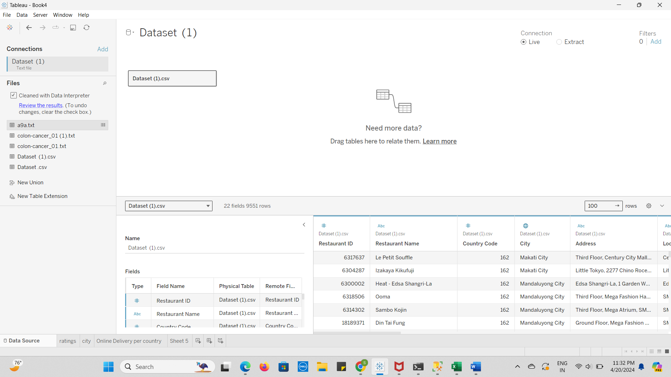

Key for Data Interpreter:

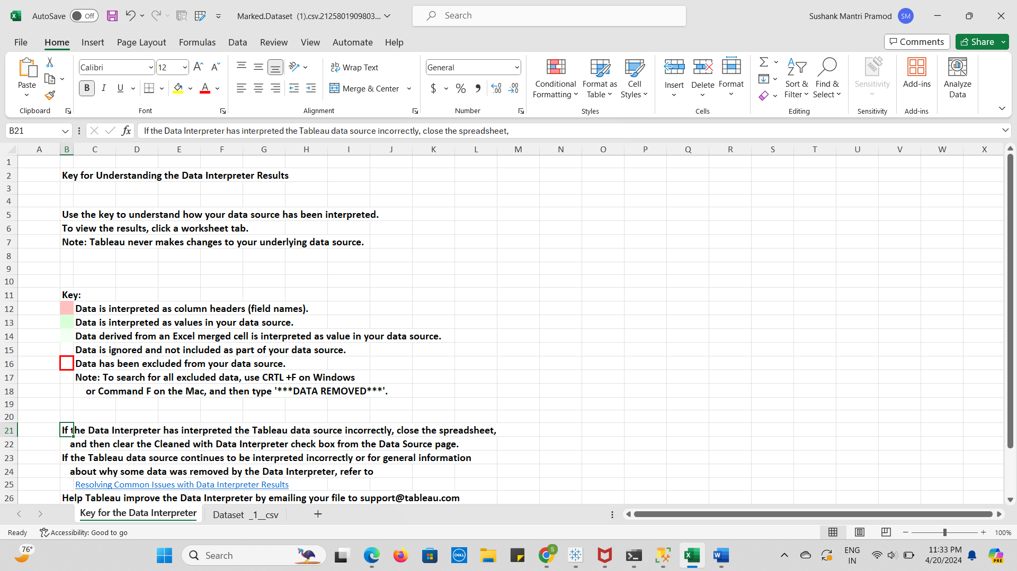Final Result after Data Interpretation:

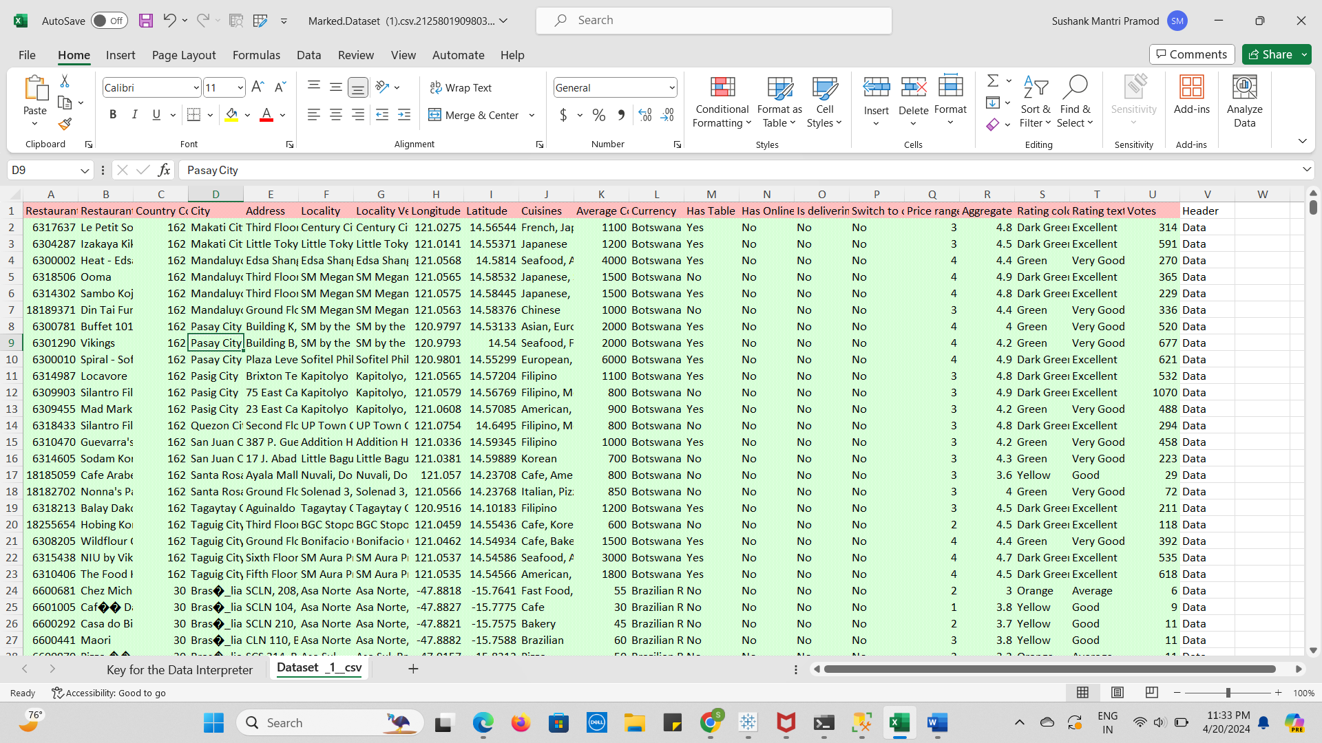

**References:**

**Dataset Link:** [**https://www.kaggle.com/datasets/mohdshahnawazaadil/restaurant-dataset**](https://www.kaggle.com/datasets/mohdshahnawazaadil/restaurant-dataset)

**Mural Link:** [**https://app.mural.co/t/sushank5030/m/sushank5030/1712263790900/fc5f85f8e428ec23711fdae39d82782efc901bf5?sender=ueb02cce70d4e3ee0d5484586**](https://app.mural.co/t/sushank5030/m/sushank5030/1712263790900/fc5f85f8e428ec23711fdae39d82782efc901bf5?sender=ueb02cce70d4e3ee0d5484586)

**Tableau Link:**

**https://public.tableau.com/views/FinalProjectbb/Dashboard1?:language=en-US&publish=yes&:sid=&:display_count=n&:origin=viz_share_link**